### Semester One Examination, 2020

### Question/Answer booklet

# 12 SPECIALIST MATHS

**UNIT 3**

## Section Two:

## Calculator-assumed

Your Name

Your Teacher’s Name

## Time allowed for this section

Reading time before commencing work: ten minutes

Working time: one hundred minutes

## Materials required/recommended for this section

***To be provided by the supervisor***

This Question/Answer booklet

Formula sheet (retained from Section One)

***To be provided by the candidate***

Standard items: pens (blue/black preferred), pencils (including coloured), sharpener, correction fluid/tape, eraser, ruler, highlighters

Special items: drawing instruments, templates, notes on two unfolded sheets of A4 paper, and up to three calculators approved for use in this examination

## Important note to candidates

No other items may be taken into the examination room. It is **your** responsibility to ensure that you do not have any unauthorised material. If you have any unauthorised material with you, hand it to the supervisor **before** reading any further.

|  |  |  |  |  |  |
| --- | --- | --- | --- | --- | --- |
| **Question** | **Marks** | **Max** | **Question** | **Marks** | **Max** |
| **8** | **5** |  | **17** | **12** |  |
| **9** | **8** |  | **18** | **10** |  |
| **10** | **10** |  |
| **11** | **9** |  |
| **12** | **12** |  |
| **13** | **5** |  |
| **14** | **9** |  |
| **15** | **8** |  |
| **16** | **10** |  |

**Structure of this paper**

|  |  |  |  |  |  |
| --- | --- | --- | --- | --- | --- |
| Section | Number of questions available | Number of questions to be answered | Working time (minutes) | Marks available | Percentage of examination |
| Section One:  Calculator-free | 7 | 7 | 50 | 50 | 34 |
| Section Two:  Calculator-assumed | 11 | 11 | 100 | 98 | 66 |
|  |  |  |  | **Total** | 100 |

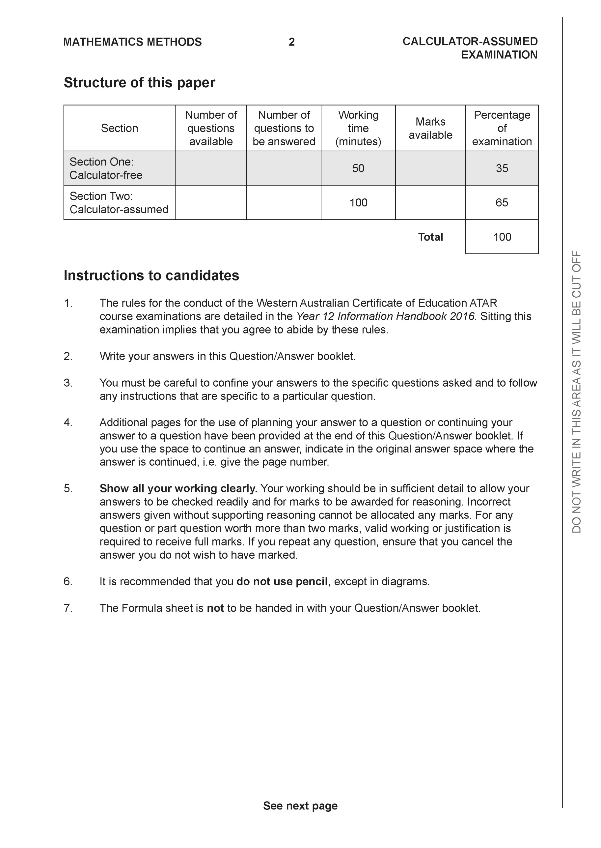

**Section Two: Calculator-assumed (98 Marks)**

This section has **11** questions. Answer **all** questions. Write your answers in the spaces provided.

Spare pages are included at the end of this booklet. They can be used for planning your responses and/or as additional space if required to continue an answer.

● Planning: If you use the spare pages for planning, indicate this clearly at the top of the page.

● Continuing an answer: If you need to use the space to continue an answer, indicate in the original answer space where the answer is continued, i.e. give the page number. Fill in the number of the question that you are continuing to answer at the top of the page.

Working time: 100 minutes.

**Question 8 (5 marks)**

Consider the following system of linear equations with  are constants.



Determine all the values of such that:

1. There will be an unique solution
2. There will be infinite solutions
3. There will be no solutions

**Question 9 (8 marks)**

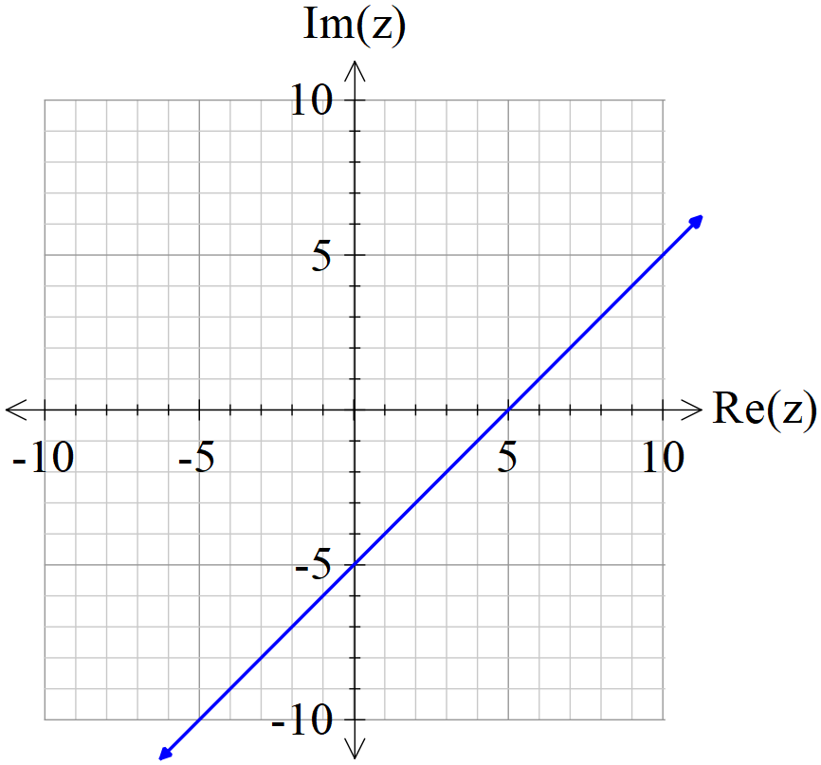

Consider the locus of  which is drawn above.

1. If the locus above can be defined by , determine the constants

. (2 marks)

1. Determine the exact minimum value of  on the locus above. (3 marks)
2. Sketch the new locus of on the axes above showing major features.

(3 marks)

**Question 10 (10 marks)**

Let .

(a) Express the complex number  in polar form using the principal argument in radians.

(2 marks)

The complex number  is drawn in the complex plane as shown below.

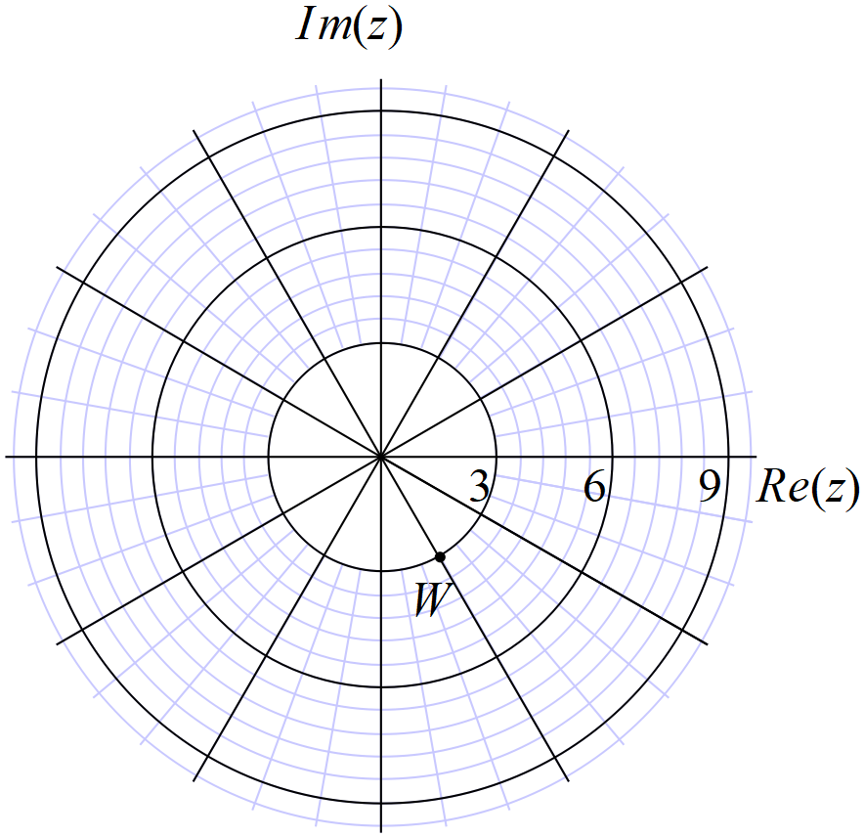

(b) Express the complex number  in polar form using the principal argument (2 marks)

(c) Plot on the axes above, the complex numbers . (4 marks)

(d) Explain geometrically the transformation effect of multiplying by . (2 marks)

**Question 11 (9 marks)**

Consider the plane .

(a) Determine the vector equation of a line that passes through Point A and is perpendicular to the plane above. (2 marks)

(b) Hence or otherwise, determine the distance of point A from the plane above to one decimal place. (3 marks)

(c) Consider the sphere  where  is a real constant. Determine the value(s) of  to two decimal places so that the line  is a tangent to the sphere.

(4 marks)

**Question 12 (12 marks)**

Consider the plane  shown below with the following points .

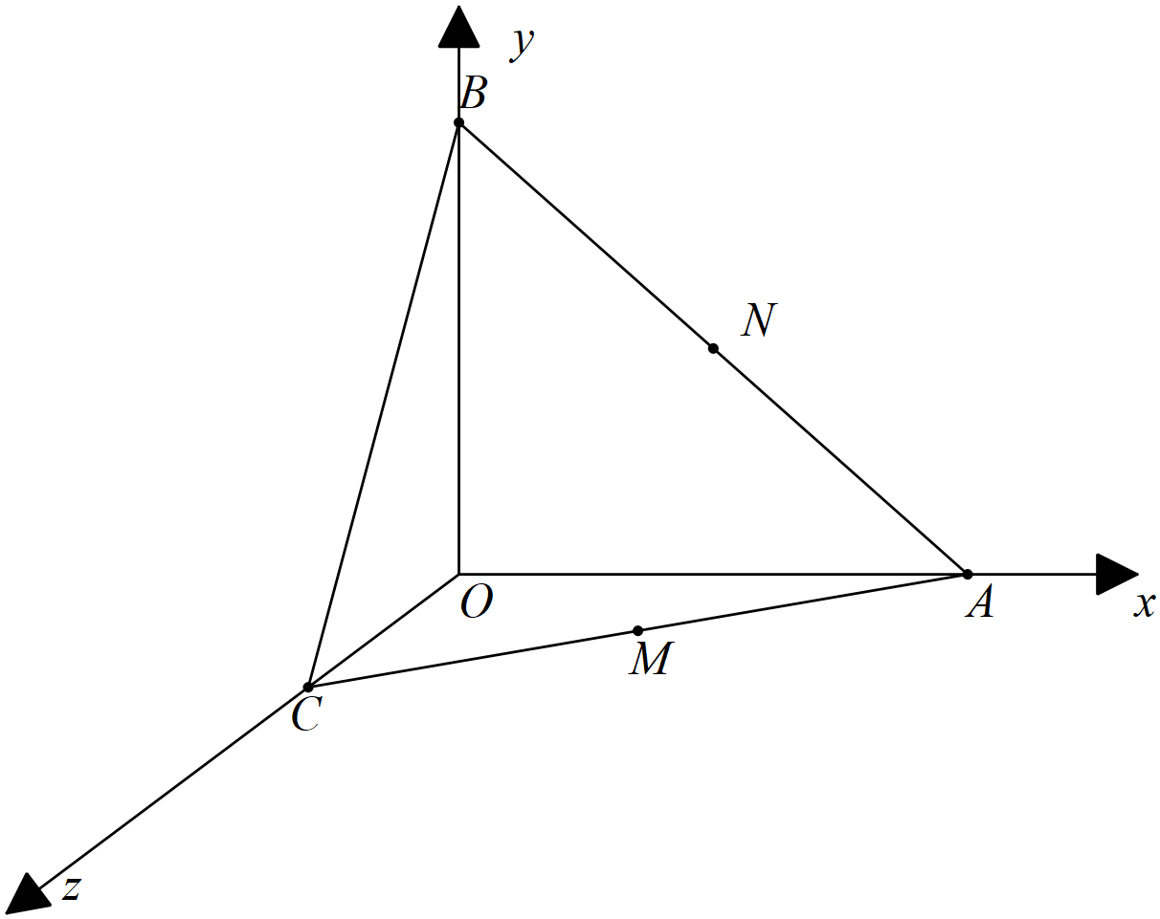

Let  be the midpoints of  respectively.

(a) Determine the position vectors  (2 marks)

(b) Using vector methods, show that  trisect each other, that is divide each other in the ratio . (4 marks)

Q12 cont

(c) Determine using **vector methods**, the area of the face  (3 marks)

(d) Determine the cartesian equation of the plane . (3 marks)

**Question 13 (5 marks)**

Consider the plane  , which is parallel to a second plane . Given that point  is a point on plane , determine the distance of point  from the plane  to two decimal places.

**Question 14 (9 marks)**

Particle A started to move with constant velocity  at 11:30am, at 1pm the particle was at position .

(a) Determine the position of the particle A at 11:30am. (2 marks)

Particle B left  at 1pm, moving with constant velocity .

(b) Determine the distance between the two particles at 2pm that day. (3 marks)

(Two decimal places)

(c) Determine the closest distance between the two particles, if they maintain their constant velocities, and the time it occurs. (Two decimal places) (4 marks)

Q14c continued

**Question 15 (8 marks)**

A particle moves with acceleration  at time  seconds.

Initially the particle is at the origin with velocity 

(a) Determine the velocity function at time  seconds. (2 marks)

(b) Determine the first two times that the particle is moving parallel to the x axis. (3 marks)

(2 decimal places)

(c) Determine the **exact** distance of the particle from the origin at time  seconds.

(3 marks)

**Question 16 (10 marks)**

Consider the following motion defined by  at time  seconds.

(a) Describe the motion. (2 marks)

(b) Determine the initial velocity and acceleration. (3 marks)

(c) Determine the time(s) that the velocity is perpendicular to the acceleration. Justify.

(3 marks)

(d) Determine the exact distance travelled in the first 10 seconds. (2 marks)

**Question 17 (12 marks)**

At midday two rockets, A & B were observed moving in the sky above moving with constant velocities. Their positions and velocities were recorded as below at midday. They appear to have been moving for a number of hours and will continue to do so for many more.



Let  = number of hours from midday.

(a) Determine for Rocket A, the position vector from the origin at time hours. (2 marks)

(b) Determine the cartesian equation for the path of Rocket A. (2 marks)

(c) Show that the rockets will not collide after midday. (2 marks)

Q17 continue-

(d) Determine the times **after** midday that the rockets are less than 60 km apart.

(3 marks)

(e) Determine the closest approach **from midday** and the time that this occurs.

(3 marks)

**Question 18 (10 marks)**

Consider a tennis ball moving with velocity  that hits a surface with a normal vector of  as shown in the diagram below.

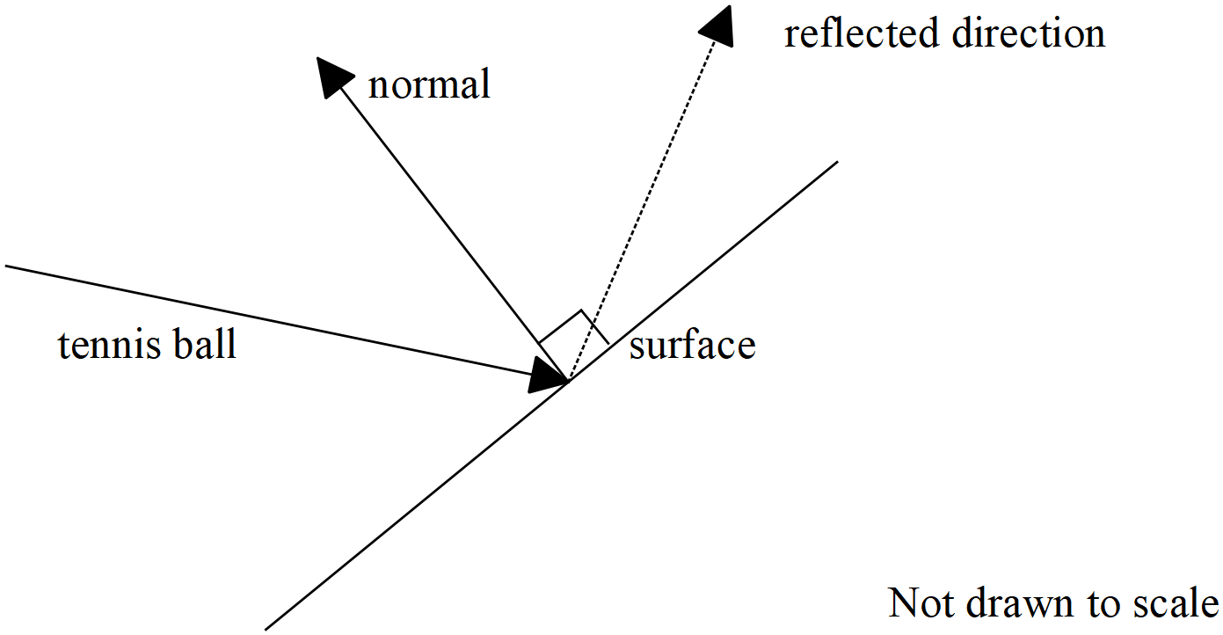

(a) Determine the angle between the velocity vector and the normal vector to two decimal places in degrees. (2 marks)

Let the unit vector  be parallel to the reflected direction of the tennis ball. This vector is in the same plane as the velocity and normal vectors above.

(b) Given that the tennis ball is reflected such that the angle with the normal equals that of the incident acute angle with the normal. Show that  when rounded to three decimal places. (3 marks)

Q18 continue-

(c) Derive another two independent equations for . (3 marks)

(e) Solve for to two decimal places. (2 marks)

**Working out space**

**Working out space**